United Budgerigar Society Inc.
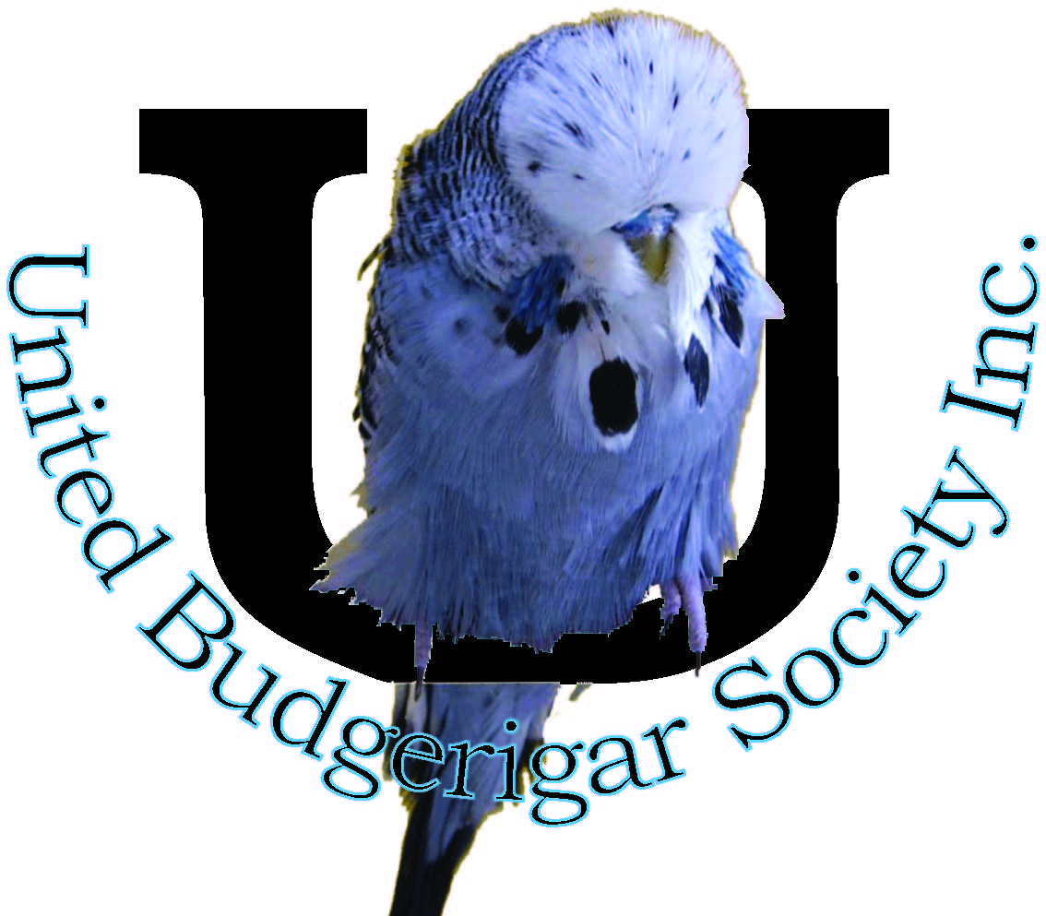
Secretary: Brian Reynolds
PO Box 229
Kerrimuir 3129
PH: 0448 654 607
E: info@unitedbudgies.org.au

Show Preparation
Courtesy of Jim Fletcher – Tasmania

- Eight weeks out
  - Decide which birds you propose to enter in the first show of the year
  - Check birds for broken primary tail and flight feathers, removing any found broken with the feather shaft still in place. It is vital to ensure all the shaft is removed
  - Give the birds a light spray with water before returning them to the aviary
- Six weeks out
  - Catch the birds up and check progress of feather growth in those that had tail and flight feathers removed
  - This is a good time for a first check of the spots
  - It is vital to re-check all the team for damaged tail and flight feathers, it is now too late to remove as discussed above. It takes 6-8 weeks for primary tail feather; 6 weeks for primary flights to fully mature, try repairing these damaged feathers by dipping in very hot water and running your thumb and pointer finger over the feather
  - Give the birds a good spray place them in training cages. If the weather is warm use cold water but if cold weather then use warm water
- Four weeks out
  - Vital to check for missing or damaged spots and remove any that are damaged. It takes 4 weeks for a spot feather to mature
  - Check the rings on each bird to ensure it moves freely and is not clogged up. Remove any split rings that may have been used to identify special features such as splits etc.
  - Give the birds a good soaking with warm or cold water before placing them back in training cages; separate the cocks from the hens
  - Good idea to increase the food given to the birds at this stage (watch the amount of hulled oats as some birds may tend to put on too much weight)
  - This is also a good time to treat for worms and canker
  - Commence show cage training: with those that will not settle, leave in a show cage overnight
- Three weeks out
  - By now you should be spraying the birds every second day
  - Bent or twisted tail and flight feathers should be straightened every day by dipping the feather in hot water and running your thumb and pointer finger over the feather
  - Check the feather re-growth any new spots should be coming down
  - Keep your training cages reasonably clean to prevent the birds from getting dirty
- Two weeks out
  - Spray the birds every day this week. This will really assist new feather growth
  - Bent or twisted tail and flight feathers should be straightened every day by dipping the feather in hot water and running your thumb and pointer finger over the feather
- One week out
  - Birds should be coming to peak condition; all new feather growth should be nearing completion
  - Keep spraying daily until Friday before show
  - If you prefer to cut the multiple spots out, it is a good time to start as it can take a few days to complete this task for multi spotted birds (Jims preferred method as you only have to do once in a show season)
  - Plucking of spots should be done no later than two days out to ensure those spots left are lying in the correct position
- One day out
  - Check for bent feathers and straighten as required
  - Don’t feed greens today
- Morning of show
  - Box the birds in the correct show cage, if any feathers a bent straighten as above
  - Ensure cage is correctly locked

Having done all this it is now up to the birds to strut their stuff, don’t let the birds down by exhibiting in a dirty cage.

The rest is down to having a bit of luck on the day.

Web: www.unitedbudgies.org.au Facebook: United Budgerigar Society Inc.

