United Budgerigar Society Inc.
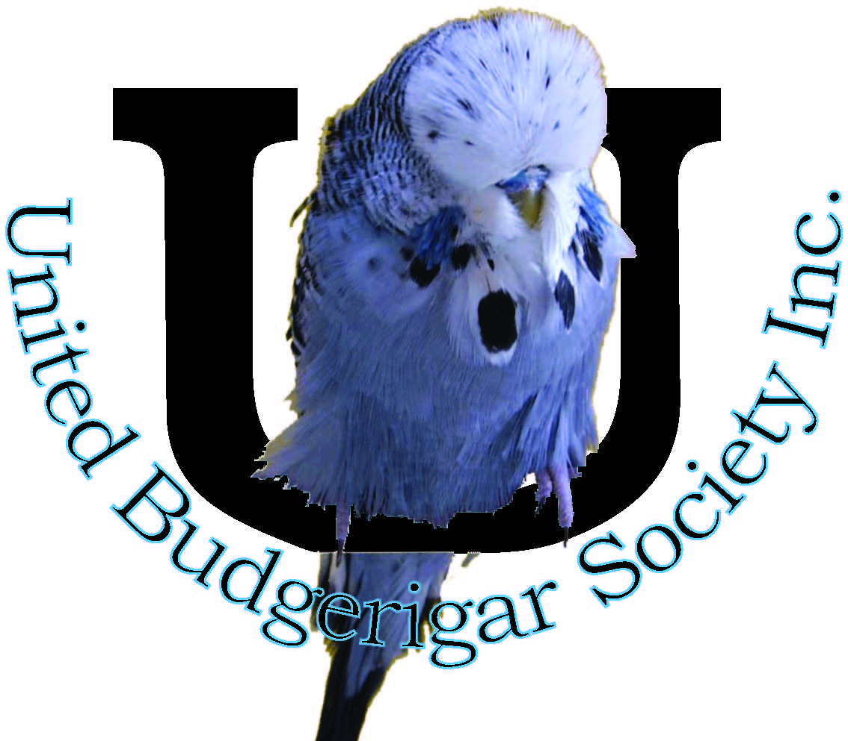
E: info@unitedbudgies.org.au
Web: www.unitedbudgies.org.au
Facebook: United Budgerigar Society Inc.

CODE OF CONDUCT
This document, the UBS Code of Conduct is a guide to members of the UBS, which summarises UBS’s expectations of its members, and that of our guests at club functions. Guests include our family, friends, and visitors.
The UBS Code of Conduct has been developed to ensure a safe, friendly and respectful place for members, and our guests, to gather in the spirit of cooperation, relaxation, good will, fun and friendly competition.
The UBS Code of Conduct differs from rules in that it provides guidance on what is acceptable behaviour. It is by no means a comprehensive guide, and members and our guests should exercise appropriately acceptable behaviour, within the context of our society and applicable law, when situations arise that are not referred to below.
UBS Code Of Conduct
All members and our guests are expected to conduct themselves in a manner that:
- Creates an environment and culture that is reflective of the personal integrity and respect consistent with the wider community where it is expected that we will conduct ourselves with honesty, integrity and good sportsmanship. This same integrity, honesty and good will is expected at all times whether at a show or club social function.

- Does not denigrate the UBS in any way, shape or form either in person, through the media or through any form of social media
Is free of discrimination or any form of harassing behaviour including personal, sexual, racial, religious or other forms of harassment.

- Acknowledges the UBS as a family friendly environment and, therefore, refrains from using obscenities and loud boisterous behaviour inappropriate for children and respectable taste.

- Observes appropriate social etiquette at all times when representing the club at any event.

- Understands that the Club’s committee is responsible for instructing members in the performance of their duties at club events and shows.

- Is vigilant in reporting real or perceived safety hazards to the Club's committee.
- Does not denigrate, talk down to, or verbally abuse any UBS members or guests, and does not create unnecessary strife and divisiveness in the UBS through any manner.

- Does not misrepresent their position and/or authority within the UBS to others.

- Adheres to all club rules currently in force and effect

Grievance and Resolution Policy

If a UBS member has a grievance with a fellow UBS member, then the Grievance and Resolution Policy of the UBS Rules must be strictly adhered to.

Disciplinary Policy

All UBS members will make themselves familiar with the Disciplinary Policy currently in force and effect.

The inappropriate behaviour of any UBS member will be investigated, discussed and an appropriate course of action will be taken by the committee, which may include reprimand, suspension or revocation of membership in accordance with UBS Rules of Association (The Rules).

Conflict of Interests

UBS members are required to note the Conflict of Interest policy and to ensure that any potential conflicts of interest is raised with the UBS President or Secretary as soon as practical that a conflict may or have arisen.

